Security Awareness Training Plan
Student’s Name
Institutional Affiliation

Security Awareness Training Plan
Introduction
Security Awareness Training is a process that aims to teach employees of any organization the importance of cyber security. In addition to this, it allows workers to know what to do in instances of breach or who to alert if they have a problem with their computers. In many instances employees do not see the importance of cyber security and see it as regulations that hinder them to do certain tasks that they would likely be doing if they were no limitations (Liaropoulos & Tsihrintzis, 2014). However, according to research if an institution is not online active for ten days and more the amount economic sabotage that will happen will be impossible to recover from. Computers in this modern time are used to transfer large amounts of information that vary from transferring messages through email to backing up important institutional information.
Therefore the article that follows will major on developing a security training plan that will aim to educate employees and make them actual participants in the process of acquiring new insights, knowledge and skills. The process of developing a capable security awareness training program must be tailored to suit the needs of each and every employee regardless of which department they work (Bullock, Haddow & Coppola, 2012). In this case training will ensure that employees are aware of their position and which part they have to play to make sure the plan works smoothly and without any glitches. Can you imagine conducting business without an email or hand-writing a report which will later be created using a type writer? How much time would it take to do such an activity? Furthermore, what if the business has a lot of activities to cover and the type writers are limited, how much time and money will the organization lose? It is the very essence of training.
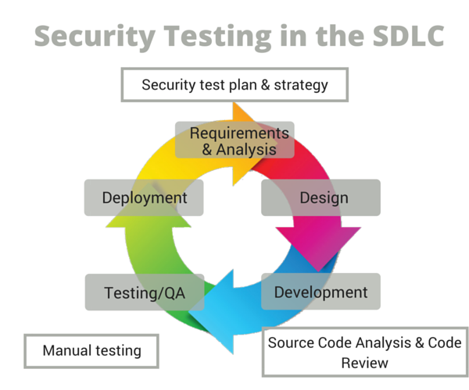
Figure 1 shows an elementary design of the training process.
Step one: Stating the Objective
It is important to state the reasons for cyber security and make sure each and every employee understands why they should be cautious and be alert if they observe anything unusual on their systems. To protect the interest and integrity of the organization workers should understand their responsibilities fully and learn how to always adhere to them. To attain the above objective employees must be trained the right procedures and policies which they should follow to ensure the security of the firm’s systems (Bidgoli, 2017). And, as such the workforce must be in a position that they understand the basics of Information Technology (IT) and be able to apply the instruction to everyday work environment. The first step therefore, is to explain the objectives and goals of the security awareness program. When conducting this initial stage significant issues to put in place include training employees how to overcome obstacles and what to do when facing resistance.
In addition to this it is necessary to train your employees on the following issues to make sure they are equipped with information that is helpful to them and the organization.
- Workers should understand that there are cyber threats that can harm the safety of physical assets and stored data.
- Employees should know the risks of transferring data through open networks and know their position and what to do to protect the organization.
- Employees should know rules, regulations and laws that go hand in hand with cyber security which include and not limited to copyright and privacy violations.
- Workers should be coached on departmental policies that they should follow when using their computers on the organizational open network.
- Workers should be taught how to protect top secret data that belongs to the organization and its members.
- Lastly employees should be given procedures on whom to report to when they notice any malware on their systems.
Step two: Content Decision
The foundation of a Security Awareness Training program lies on the work put in to sensitize and make employees aware of the many vulnerabilities and threats that cyber insecurity can hold on a business. Therefore, deciding on exactly what to protect and how to protect it should be done on the following basis; workers should know what to watch and what to do when and if they observe such activities happening on their computers. It is essential that employees are trained on the best practices when creating, processing, transmitting, and storing different types of data (Bullock, Haddow & Coppola, 2012). The very significance of this activity is to make the workforce cautious and aware of the what they do and how they should do it so that they cannot invite hackers of computer viruses into the system which may prove difficult hard to get rid of. Importantly the level and type of content is dependent upon the needs of the enterprise.
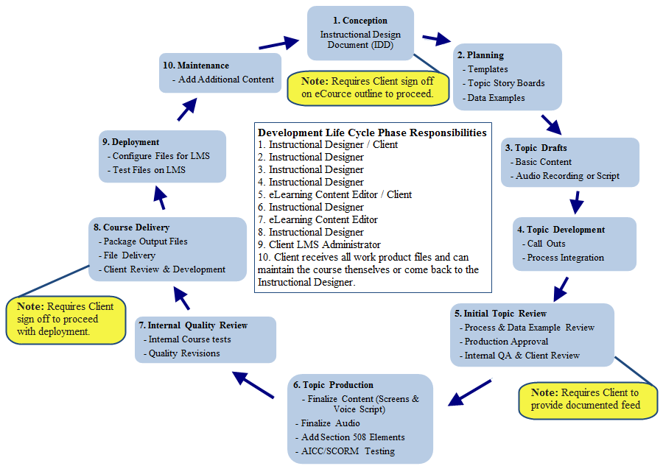
Figure 2 is a more complex design of the process.
Step three: Implementation
Without saying this is the most important stage since without effectively spreading the message to employees security awareness will be taken for granted and when it happens the organization will be at risk in facing security threats. Many options are available at the organizational disposal to carefully and accurately spread the message to their employees. They include and not limited to the following; catchy slogans, posters, video tapes, posters, bulletin boards, monthly or weekly e-mails, cartoons, computer based messages and security banners (Liaropoulos & Tsihrintzis, 2014). It is important to always remember that to make the information stick in the minds of the employees one should introduce fun, exciting, positive and motivational messages that makes them of more that the message. Furthermore, the messages may be extended through the use of gifts engraved with cyber security slogans on items that they use daily such as key chains, security identification cards and lunch carryon bags.
In addition, to memorable items the organization should also remember that awareness is a never ending affair that requires constant work to ensure employees do not forget or relax. The message conveyed by the institution should always be followed through and in many instances should be displayed differently after a period of time to eliminate monotony and boredom (Smith, 2014). Therefore, this activity calls for the Information Technology department to be creative and always come up with new ways to keep the organization enlightened and excited about the cause. The message conveyed should always remain in the moment and aim to adhere to changing policies, rules and regulation of both the organization and the nation at large. And, if any changes are to happen employees should be informed prior or immediately to ensure that they follow the rules correctly.
The last issue in the implementation stage is the message conveyed should be brief and simple to comprehend and remember. The implementation step should not be expensive for the organization in most cases it should take the organization minimal cost. However, the management should ensure that the organization fully knows what is demanded of them and how best they should do it (Herold, 2011). If the firm does not have a capable public relations department it is necessary to outsource the service from a capable institution that has the ability to carefully and accurately share the interests of the management to the employees. Furthermore, the service should not be costly for the organization or hinder workers to effectively handle their day to day activities otherwise the activity will be destructive and in that capacity it will not achieve its objective.
Step Four: How to Overcome Obstacles
In any organization and in activity that requires employee assistance there ar issues that should be aligned to make sure that everything goes as planned. Security awareness training acts under the same criteria and in relation to that statement it is important that the management of the organization manages to fully fund the awareness without any glitches to ensure the message is fully understood (Timm, Romer, Bunn, Kumaraguruparan & Studholme, 2015). As an example the administration are required to offer annual support to the program and ensure that the implementation stage is paid for and all stakeholders are taken care of. If the implementation step is not well supported the training program will and may fail. And, if employees sense that the management is not for the plan they too will state retaliating against the plan and take it for granted and this will be the inception of security issues. Therefore, it is important to put up a plan that consists of the objectives, cost approximates that include calculation for labor, materials, time and deliverables.
In addition to funds planning they will be retaliation from a group of the employees who don’t fully understand the essence of cyber security to the firm and to the profitability of the organization. Practices such as not attending briefings and monthly meetings will be frequent if the message conveyed by the organization is not properly conveyed. Furthermore, they will be employees that will create a negative environment in the workplace and aim to undermine the objectives of the IT department (Bidgoli, 2015). If such instances happen the management should look into the reasons that are making the employees have such sentiments on the security awareness program and later device ways to smooth line their activities and later boost their firewalls to ensure those activities do not harm the organization later. Regardless of resistance at the workplace many of the employees will aim to do well at their job and abide by the policies and rules set in place. Therefore, the management should find ways to streamline the process and ensure no employee feels that their rights of freedoms are being abused and the process will be smooth.
Step Five: Evaluation
Evaluating the progress of the security awareness training is the final step and it deals with assessing whether the employees have assimilated the objectives of the process into their day to day activities. It is important since this is where the organization knows what works ans what does not. The stage does not require the management to carry out any comprehensive qualitative or quantitative data rather they should check on the behavior and interpretation of the process (Herold, 2011). And, by noticing the change in character and perception it will be easy for the administration to know what to change and what should remain the same. Apart from measuring the atmosphere in the organization the IT department can carry out other activities such as offer the employees a quick questionnaire that they may fill out and give the management suggestions on what to improve.
Other ways that can be used is using word of mouth where members of the IT department can take it upon themselves and casually ask other employees during lunch or breaks what they think about the training and what they would like improved or changed. The next method is to keep track of how many incidents that happened before the training was performed and how many have happened after (Speed, 2012). The process will give clear results since if the cases are lesser it will mean that the employees are actually paying attention to what they have been taught. If the results state that they are more it will show that the implementation failed and workers have not adopted the new changes. The next method the administration can use to perform random spot checks into offices to ensure employees are logged onto the proper sites and their firewalls are working properly.
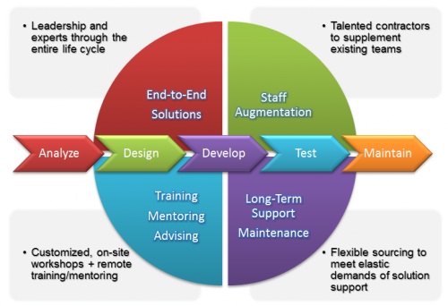
Figure 3 is a sophisticated diagram
Conclusion
The paper above is created for the sole purpose of creating a Security Awareness Training Plan. It has covered a variety of areas as they follows; the first is an introduction that aims to explain what security awareness is and its essence on any and all organizations. Stages of the plan have followed, the first being stating the objective of the training. In this area it has discussed that it is vital to explain to the employees the importance of cyber security (Bidgoli, 2015). The next stage is content decision and in this area the paper has explained that choosing what workers should consider important is integral to the training and it lays the ground work for implementation which is the next step. In the implementation area methods are discussed of how the organization can carefully inform their employees on what and how to do it. The fourth stage is how to overcome obstacles and in this area it has been observed that there will be retaliation and how to cope with it. The fifth and last step is evaluation of the success of the training process it is significant since it shows if the implementation stage is successful.

References
Bidgoli, H. (2015). MIS6. Boston, MA: Cengage Learning.
Bidgoli, H. (2017). Mis + Mis Online, 1 Term 6 Months Access Card. City: South-Western Pub.
Bullock, J., Haddow, G. & Coppola, D. (2012). Introduction to homeland security. Boston, MA: Butterworth-Heinemann.
Bullock, J., Haddow, G. & Coppola, D. (2012). Homeland security: the essentials. Place of publication not identified: Butterworth-Heinemann.
Herold, R. (2011). Managing an information security and privacy awareness and training program. Boca Raton: CRC Press.
Liaropoulos, A. & Tsihrintzis, G. (2014). Proceedings of the 13th European Conference on Cyber Warfare and Security ECCWS-2014 : the University of Piraeus, Greece 3-4 July 2014. Reading: Academic Conferences & Publishing International Ltd.
Smith, E. (2014). Workplace Security Essentials : a Guide for Helping Organizations Create Safe Work Environments. Burlington: Elsevier Science.
Speed, T. (2012). Asset protection through security awareness. Place of publication not identified: Auerbach Publications.
Timm, P., Romer, B., Bunn, K., Kumaraguruparan, P. & Studholme, A. (2015). School security : how to build and strengthen a school safety program. Oxford, England Waltham, Maryland: Elsevier BH.

